Technical Design Document

1. Project Requirements:

You are tasked with designing and implementing a REST API for a Task Management System as part of a project management tool. This system allows users to create, update, delete, and view tasks. Each task is associated with a project and has attributes like title, description, status, priority, and deadlines.

Use Case Analysis:

This analysis specifies who are all the valid Actors who will use the system.as per brief requirement below are assumed actors of the System.
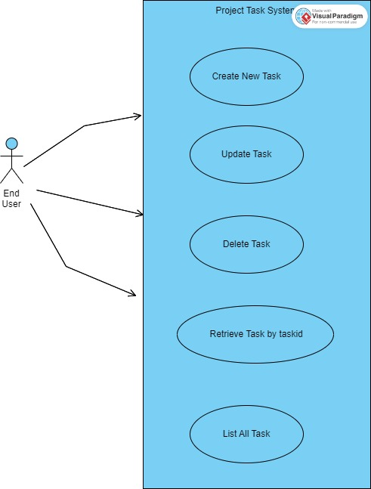

REST API Endpoints Design:

Task Management

- POST /tasks - Create a new task.

Request Structure:

Request Body:

The request body should be a JSON object containing the task details.

{
"title": "task title",
"description": "Details about Task ",
"status": "Open",
"priority": "High",
"dueDate": "2023-12-31",
"projectId": 123 // Assuming project IDs are numerical
}

Attributes:
title: A string representing the task title.
description: A detailed description of the task.
status: The current status of the task (e.g., Open, In Progress, Completed).
priority: The priority level of the task (e.g., Low, Medium, High).
dueDate: The due date for the task completion.
projectId: The ID of the project to which the task is associated.

Response Structure:

Success Response:
Status Code: 201 (Created)
Body: JSON object containing the created task's details, including a link to its project.
Example Success Response JSON:

{
"id": 456,
"title": "Implement Feature X",
"description": "Details about Feature X",
"status": "Open",
"priority": "High",
"dueDate": "2023-12-31",
"projectLink": "/projects/123" // API link to the associated project
}

Backend Implementation:

Controller Layer:

Define a POST endpoint in the controller to handle task creation requests.
Parse the JSON request body to a Task object.

Service Layer:

Implement business logic to create a new task.
Ensure the task is correctly associated with a project (check if the provided projectId exists).

Repository/Data Access Layer:

Interact with the database to save the new task.
Handle foreign key relationships with the Projects table.
Validation and Error Handling:

Validate input data (e.g., check for mandatory fields, validate date format).
Handle potential errors, such as non-existent projectId.

- GET /tasks - Retrieve all tasks.

Query Parameters:
sort: Specifies the sorting criteria (e.g., priority, deadline).
order: Specifies the order of sorting (asc for ascending, desc for descending).
page: Specifies the page number for pagination.
size: Specifies the number of tasks per page.

Example URL:

GET /tasks?sort=priority&order=asc&page=1&size=10

Request and Response Structure:

Request:
No request body is needed since it's a GET request.
The query parameters are used to control the sorting and pagination.
Response:
JSON body containing a list of tasks, each with relevant details.
Include pagination details like currentPage, totalPages, and totalItems.

Example Response JSON:

{
"tasks": [
{ "id": 1, "title": "Task A", "priority": "High", "deadline": "2023-12-15" },
{ "id": 2, "title": "Task B", "priority": "Medium", "deadline": "2023-12-20" }
// ... more tasks
],
"pagination": {
"currentPage": 1,
"totalPages": 5,
"totalItems": 50
}
}

Backend Implementation:
Controller Layer:

Define a GET endpoint in the controller.
Extract query parameters from the request.

Service Layer:

Implement business logic to fetch tasks based on the criteria.
Handle sorting logic based on the sort and order parameters.
Implement pagination logic.
Repository/Data Access Layer:

Use database queries (with ORDER BY for sorting and LIMIT, OFFSET for pagination).
Interact with the database to retrieve the required tasks.
Error Handling:

Handle potential errors, such as invalid query parameters.

In Java project using Quarkus and Hibernate, we have to create:

Define a REST controller with a method to handle the GET /tasks request.
In the service layer we will call the DAO object with Hibernate criteria or JPQL to create a query that incorporates sorting and pagination.

Return the list of tasks and pagination details in the response.

- GET /tasks/{taskId} - Retrieve a specific task by its ID.

Request Structure:

Path Parameter:
taskId: The unique identifier of the task to be retrieved.
URL Example:
GET /tasks/123 - Retrieves the task with ID 123.

Response Structure:
Success Response:
Status Code: 200 (OK)
Body: JSON object containing the task's details, including its association with a project.

JSON Body Example:

{
"id": 123,
"title": "Implement Feature X",
"description": "Details about Feature X",
"status": "Open",
"priority": "High",
"dueDate": "2023-12-31",
"project": {
"id": 456,
"name": "Project Y",
"link": "/projects/456"
}
}

Attributes:
id: The unique identifier of the task.
title: A string representing the task title.
description: A detailed description of the task.
status: The current status of the task (e.g., Open, In Progress, Completed).
priority: The priority level of the task (e.g., Low, Medium, High).
dueDate: The due date for the task completion.
project: An object or a link to the associated project (contains at least the project's ID and name).

Backend Implementation:

Controller Layer:

Define a GET endpoint in the controller to handle requests for specific tasks.
Extract the taskId from the path parameter.

Service Layer:

Implement the logic to retrieve the task details by its ID.
We will ensure the task data includes its association with a project.

Repository/Data Access Layer:

Use database queries to fetch the task details from the database.
Include joins or additional queries as needed to retrieve associated project information.

Error Handling:

Handle cases where the taskId does not exist.
Return a 404 (Not Found) status code if the task is not found.

- PUT /tasks/{taskId} - Update a task.

Request Structure:
Path Parameter:
taskId: The unique identifier of the task to be updated.
Request Body:
The request body should be a JSON object containing the task attributes that need to be updated.
JSON Body Example:

{
"title": "Updated Title",
"description": "Updated description of the task",
"status": "In Progress",
"priority": "Medium",
"dueDate": "2024-01-15"
// Other fields that can be updated
}

Response Structure:
Success Response:
Status Code: 200 (OK) or 204 (No Content) if no return data is necessary.
Body: Optionally, a JSON object containing the updated task's details.
Example Success Response JSON:

{
"id": 123,
"title": "Updated Title",
"description": "Updated description of the task",
"status": "In Progress",
"priority": "Medium",
"dueDate": "2024-01-15"
// Other updated fields
}

Backend Implementation:
Controller Layer:

Define a PUT endpoint in the controller to handle task update requests.
Extract the taskId from the path parameter.
Parse the JSON request body to a task object or DTO (Data Transfer Object).
Service Layer:

Implement the logic to update the task details by its ID.
Validate the input data and ensure the task with the provided ID exists.
Repository/Data Access Layer:

Use database queries to update the task details in the database.
Handle any relationships or dependencies with other entities, like projects.
Error Handling:

Handle cases where the taskId does not exist.
Validate the input data and return appropriate error messages for invalid data.
Return a 404 (Not Found) status code if the task is not found.

- DELETE /tasks/{taskId} - Delete a task.

Request Structure:
Path Parameter:
taskId: The unique identifier of the task to be deleted.
URL Example:
DELETE /tasks/123 - Deletes the task with ID 123.

Response Structure:

Success Response:

Status Code: 200 (OK) or 204 (No Content) to signify successful deletion.
Body: Typically, no response body is needed for a DELETE request. Optionally, you can return a confirmation message.
Example Success Response JSON:

{
"message": "Task with ID 123 successfully deleted."
}

Backend Implementation:
Controller Layer:

Define a DELETE endpoint in the controller to handle task deletion requests.
Extract the taskId from the path parameter.
Service Layer:

Implement the logic to delete the task by its ID.
Ensure that any dependencies or relationships are appropriately handled (e.g., removing the task from any associated projects).
Repository/Data Access Layer:

Use database operations to remove the task from the database.
Error Handling:

Handle cases where the taskId does not exist.
Return a 404 (Not Found) status code if the task is not found.
Technologies Used:
- Language -Java 8
- Frameworks- Qualkus
- Database – We can use AWS RDS service and can opt for Mysql ,Oracle as RDBMS or Keyvalue database Amazon DynamoDB (high throughput and low latency)
- Integration technologies- Apache Camel,Kafka or Rabit MQ,REST service
- Cloud technologies- AWS,Spring Cloud
- User Documentation-Swagger API.
- Project Documentation:Confluence,JIRA.
- Unit Testing-JUNIT,Jmockito.
- Code Quality Tool:Sonar,VeraCode,CheckStyle,JACOO.

Database Design:

To create an ER (Entity-Relationship) diagram for a Task Management System as part of a project management tool, we need to consider the entities involved, their attributes, and the relationships between these entities. Here's a breakdown of the key components:
Project

Attributes: ProjectID (Primary Key), ProjectName, Description, StartDate, EndDate, etc.

Task

Attributes: TaskID (Primary Key), Title, Description, Status, Priority, DueDate, ProjectID (Foreign Key), AssigneeID (Foreign Key).

TaskStatus (Optional, can be an enumeration in the Task table)

Attributes: StatusID (Primary Key), StatusName (e.g., Open, In Progress, Completed).

TaskPriority (Optional, can be an enumeration in the Task table)

Attributes: PriorityID (Primary Key), PriorityLevel (e.g., High, Medium, Low).

Relationships:

Project to Task: One-to-Many - A project can have multiple tasks, but each task is associated with only one project.

Task to TaskStatus: Many-to-One - Each task has one status, but a status can be associated with many tasks (if status is a separate entity).

Task to TaskPriority: Many-to-One - Each task has one priority level, but a priority level can be associated with many tasks (if priority is a separate entity).

Quarkus Project Implementation Steps:

Install Quarkus into Spring STS

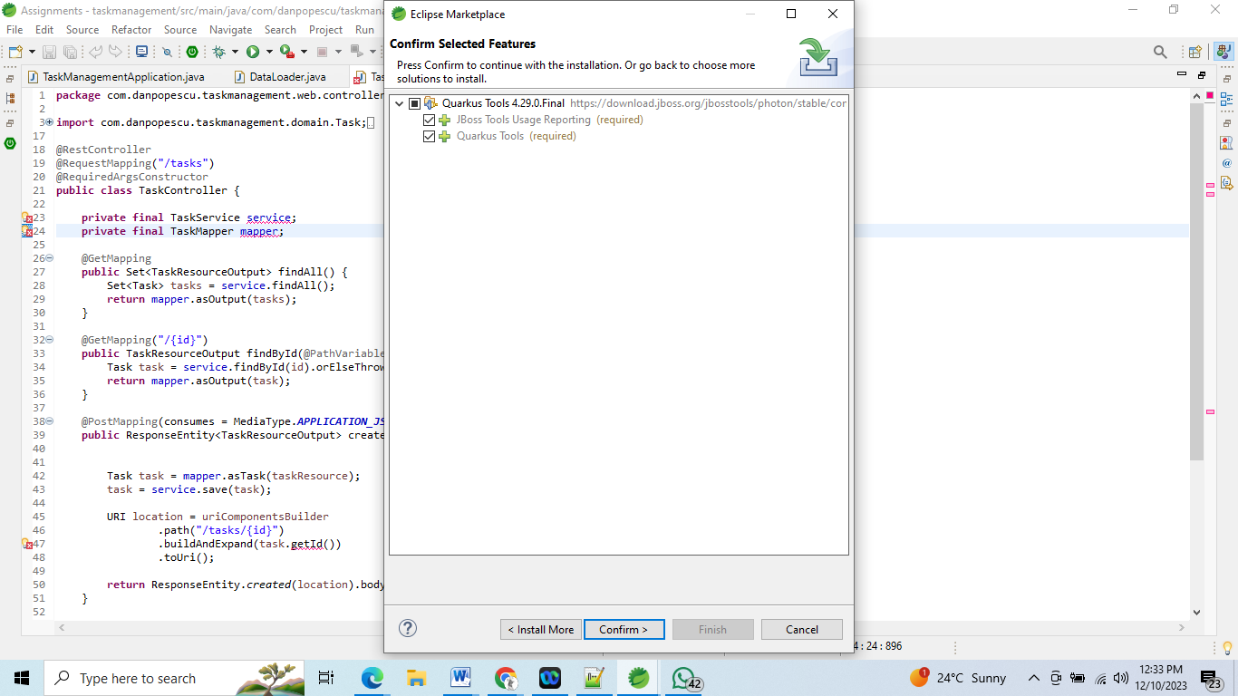

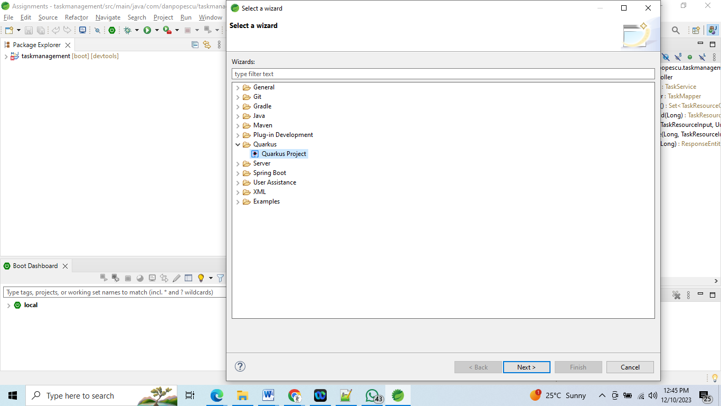

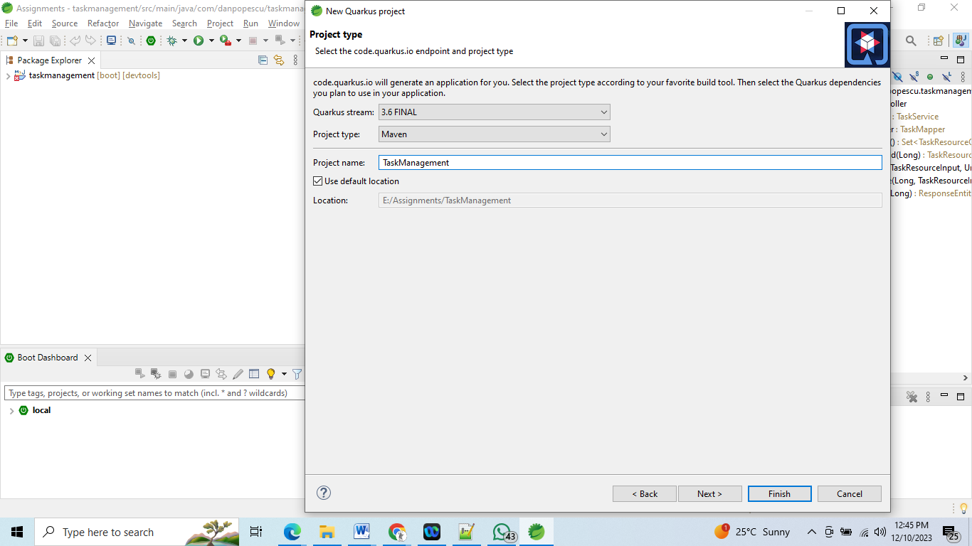

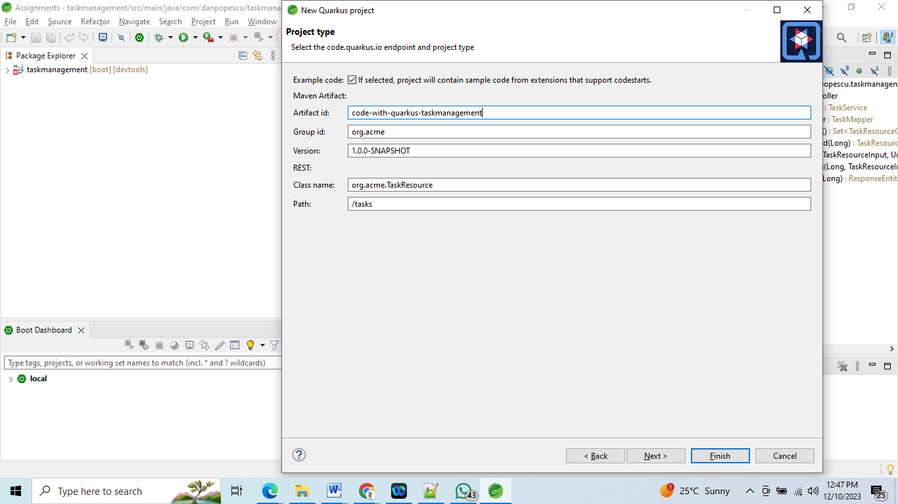

We can also create quarkus project using https://code.quarkus.io/

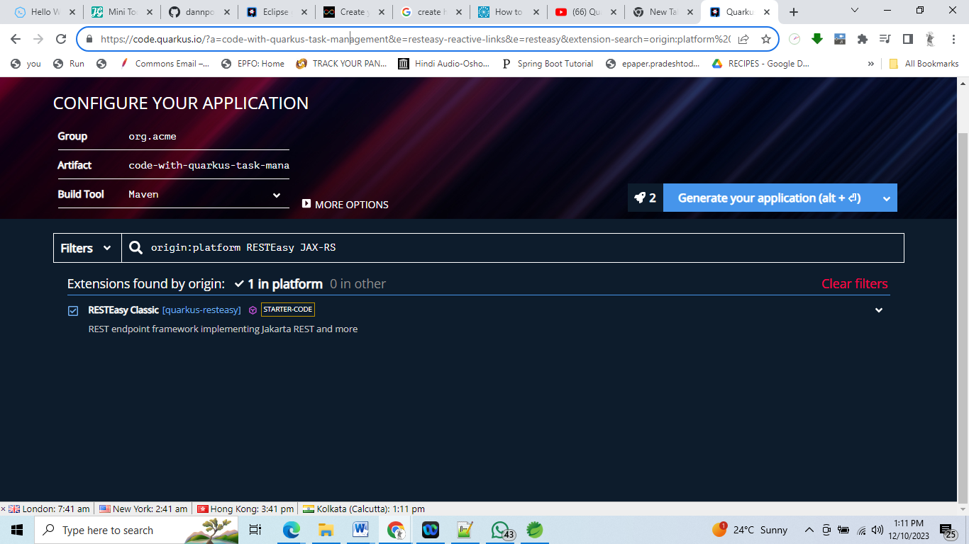

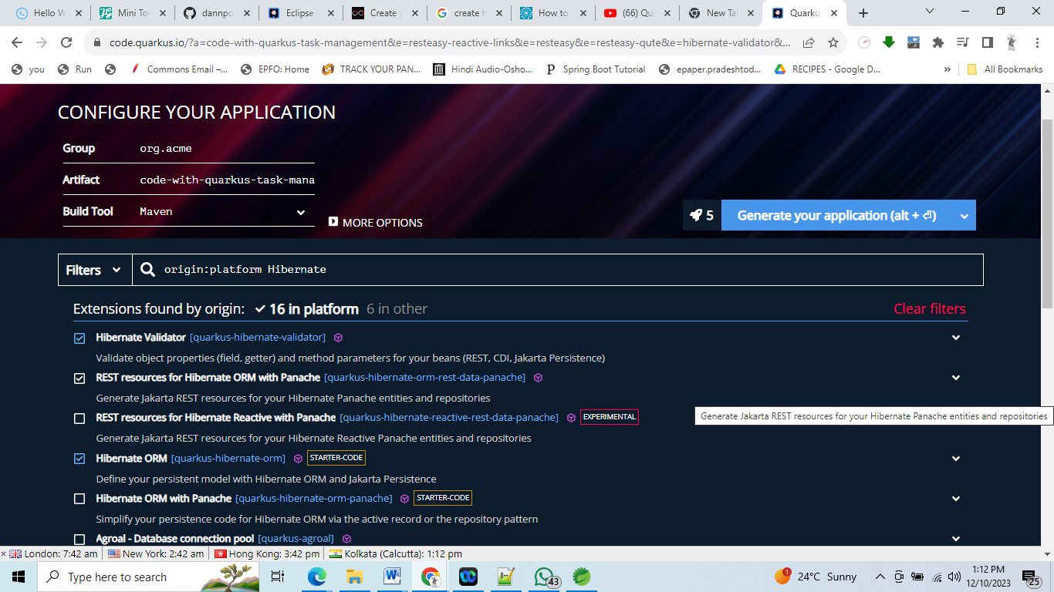

Desgin Pattern Used:

TBD

Business Logic:

We can write validation layer and use at service layer to delete task which are in specific status.

Non Functional Requirements:

Security: Only authenticated users will be allowed to access and they will be tagged to different roles which defines their action .AWS IAM can be used to define security policy for movie system.in this way we can safeguard user data.

Scalability And Availability:
When number of user accessing website increases we need to increase EC2 instances serving the application we can acheive scalability using below components of AWS:

Reduce write requests.
This can be achieved by introducing queue to process the asynchronous message.Amazon Simple Queue Service (Amazon SQS)is a highly-scalable queue, which can handle any kind of work-message load.
Auto Scaling Groups:
we can create group of EC2 instances that are treated as a logical grouping for the purposes of Automatic scaling and management.

Availability:
Use NoSQL while performing searches and mainly on data retrieval wherever High Availability needs to be achieved Casandra is recommended.
We can acheive high avaialbility of movie system by using AWS load balncing and fault tolrence services:
- Perform detailed monitoring.
- Use DNS for load balancing and floating IPs for failover.
- Use multiple Availability Zones.
- Keep traffic within one Availability Zone and use EC2 placement groups.
- Use enhanced networking EC2 instance types

Backup:
EBS and S3 for backing up data.

Payment Gateway Integration:

for example if you want to integrate Cybersource payment gateway into your application we can use AWS API Gateway and define integration point.

Service Replication:
searching specific movie and booking the ticket will be most used functionality in this system .
The service needs to replicate either Vertically or Horizontally as the quantum of search requests increases. Kubernetes provide a great way to replicate services easily using Replication Controller. also with Autoscaling enabled in AWS would enable the container to scale vertically and horizontally.

Consistency:
Use SQL where transactions should follow consistency and transaction level ACID properties need to be taken care off. Like ticket booking, updating the status from available to blocked to booked since it requires db transactions etc.
AWS RDS provides a great facility for data replication and consistency in AWS.

Transactional Scenarios: handling concurrent request may result in race condition and can corrupt the DB therefore it is important How to handle concurrency; such that no two users are able to book the same seat?

We can use transactions in SQL databases to avoid any clashes. For example, if we are using SQL server we can utilize Transaction Isolation Levels to lock the rows before we update them. Note: within a transaction, if we read rows we get a write-lock on them so that they can’t be updated by anyone else.

How to handle OWASP Top 10 Security Vulnerabilities:

1)Sql Injection:
- Make sure we do proper sanitization and validation of data.
- Use prepared stmt with parametrized query.
2)Broken Authentication:
- Example:Session Time-out, Credential Stuffing
- Among the OWASP top 10 critical vulnerabilities, is the broken authentication where attackers exploit to impersonate a legitimate user online.
- We can mitigate this issue my specifying max attempt based on IP address and use captha.

